FAKE NEWS DETECTION USING MACHINE LEARNING

Internship Project Report

Intern Details
Intern Name : Kaniyamuthu B
Intern ID : CITS862
Internship Domain : Artificial Intelligence
Project Title : Fake News Detection Using
Machine Learning
Duration : 6 Weeks

1. Abstract
Fake news has become a major challenge in today's digital world. False information spreads rapidly through social media, websites, and online platforms, influencing public opinion and creating confusion. The objective of this project is to develop a machine learning model that can identify whether a news article is REAL or FAKE. The project uses Natural Language Processing (NLP) techniques and a Logistic Regression algorithm to classify news content based on textual features.

2. Introduction
With the increasing use of the internet and social media, people consume news from various online sources. However, not all information available online is accurate. Fake news can mislead people and create misinformation. Therefore, it is important to develop intelligent systems that can automatically detect fake news.
This project demonstrates how machine learning can be used to analyze news text and predict whether it is real or fake.

3. Objectives
The main objectives of this project are:
- To build a machine learning model for fake news detection.
- To classify news articles as REAL or FAKE.
- To apply Natural Language Processing techniques.
- To understand text preprocessing and feature extraction.
- To demonstrate the practical application of Artificial Intelligence.

4. Tools and Technologies Used
- Python
- Google Colab
- Pandas
- Scikit-Learn
- TF-IDF Vectorizer
- Logistic Regression

5. Methodology

Step 1: Data Collection
A dataset containing both real and fake news articles was created for training and testing purposes.

Step 2: Data Preparation
The dataset was stored in a Pandas DataFrame with two columns:
- Text
- Label
The label indicates whether the news is REAL or FAKE.

Step 3: Feature Extraction
Since machine learning models cannot understand text directly, the news articles were converted into numerical values using the TF-IDF (Term Frequency–Inverse Document Frequency) Vectorizer.

Step 4: Model Training
The Logistic Regression algorithm was used to train the model. The model learned patterns from the dataset and identified characteristics of real and fake news.

Step 5: Prediction
After training, the model was tested using sample news articles and generated predictions indicating whether the news was REAL or FAKE.

6. Implementation
The implementation process included:
- Importing required libraries.
- Creating the dataset.
- Converting text data using TF-IDF.
- Training the Logistic Regression model.
- Predicting results for new news articles.
- Evaluating the model performance.

7. Screenshots
Dataset Creation Output:
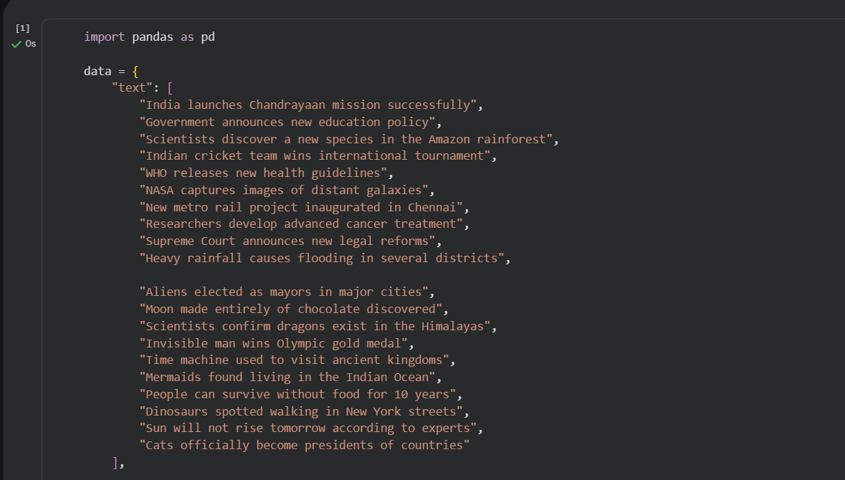
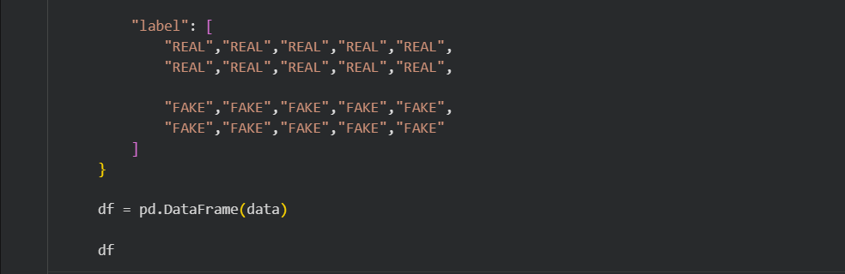
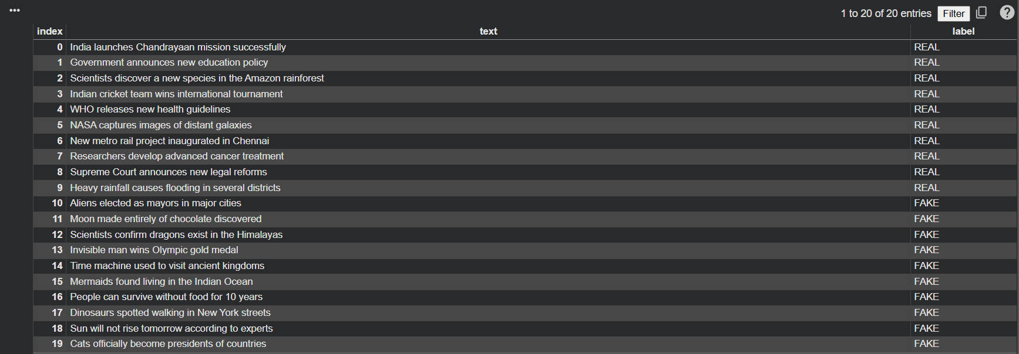

Model Trained Successfully Output:
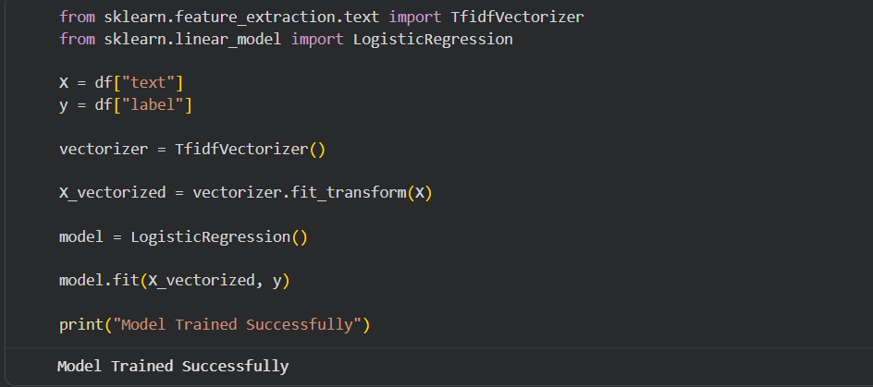

REAL News Prediction:
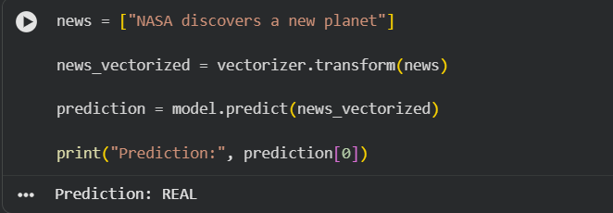

FAKE News Prediction:
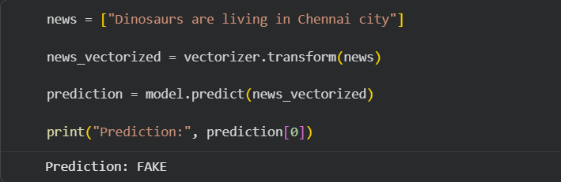
Accuracy Result:
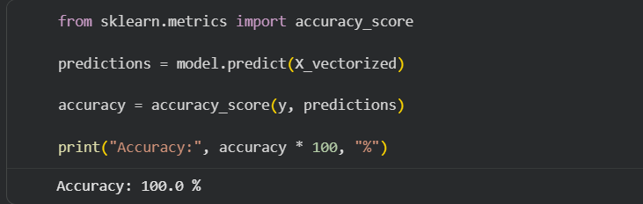

8. Conclusion
The Fake News Detection project successfully demonstrates the use of Artificial Intelligence and Machine Learning for classifying news articles. By using TF-IDF Vectorization and Logistic Regression, the system can distinguish between real and fake news based on textual content. This project highlights the importance of AI in combating misinformation and improving the reliability of online information.

References
- Python Documentation
- Scikit-Learn Documentation
- Pandas Documentation
- Google Colab Documentation
- Machine Learning and Natural Language Processing Resources

